Department of Sociology

Title of the Method: Inquiry Based Teaching
Class: TYBA AND SYBA
Concept:Culture is a complex concept that cannot be easily defined, the widely accepted definition is that ‘Culture is everything that human beings have created around them in a given space’. The fact that culture as a concept is multidimensional, this makes teaching and learning about culture even more complex. Culture is dynamic and ever changing, The dynamic nature of culture brings a number of challenges and concerns for teachers trying to choose relevant teaching materials and activities (Savignon&Sysoyev, 2005). While textbooks often depict culture as static, the digital media, authentic products and texts provide a more dynamic environment through direct access to most current practices, perspectives, and products. The teachers’ major task is to bring both language and culture in their social reality (Lange, 1999), in order to make sure that the students do not possess incomplete or outdated knowledge about the target language and its culture. With the development of the 3P model, according to Lange (1999), there is a new focus“ on learner performance with products, practices, and perspectives” (p. 106).
This paradigm shift from passive receivers of information to active constructors of knowledge places the learners in the role of inquirers who investigate and discovers their own, as well as a second or third culture. In inquiry-based teaching, the students are engaged in meaningful learning that fosters higher-order thinking to assist students in uncovering and exploring the hidden meanings and significances embedded in culture. According to Tang (2006), “not only should students know the what and how about a culture, but also the why. It is the why, as has been argued previously, that enriches and sustains the memory about a second culture accumulated in the learning process” (p. 89). Since the Standards promote making meaningful connections and comparisons, it is important that students develop reasoning skills to make these kinds of connections and comparisons. One of the major goals for a teacher is create inquiry questions that provoke interest in the target culture and will lead to important discoveries about the culture and people and thus, develop understanding of culture
Objectives:
- To foster higher order thinking
- To uncover and explore the hidden meanings and significance of a given cultural aspect of Cuisine
- To know why cuisines develop and the role it plays in society
- To develop team and leadership skills
Procedure
The Class was divided in to four groups, selected by the group leaders. Each group consisted of 14 to 15 members. The teaching-learning process being outcome based ,an integrated approach of Continuous Assessment(C.A) through learning outcome was used. The Teacher introduced the idea of cuisine and its role in culture and varied theoretical aspects. Later the students were expected to research in groups and demonstrate their inquire using the three P’s model of products, practices, and perspectives.
The continuous assessment was based on unit 3,
Unit 3: Understanding the Cuisines of Goa
3.1: The Sociology of food.
3.2: Portuguese influences in food.
3.3: Religious differences in cuisines.
3.4: Goan food its preparation (Sociological perspective)
Outcome:
This was based on the assessment, which involved demonstration and analyses of Goa Cuisine. Learners in their respective groups had to prepare four authentic main course dishes across any two religious communities and two sweet dishes and explain the preparation and its evolution using sociological theories of westernization, assimilation and adaptation, social significance and relevance and demonstrate the same. The students were assessed on the parameters using a rubric i.e. Creativity and Group Work, Authenticity, Presentation and Conceptualization. A total of 20 Marks were assigned. (See Appendix-3: Rubrics for Goan Cuisine)
Group Photographs
Group 1
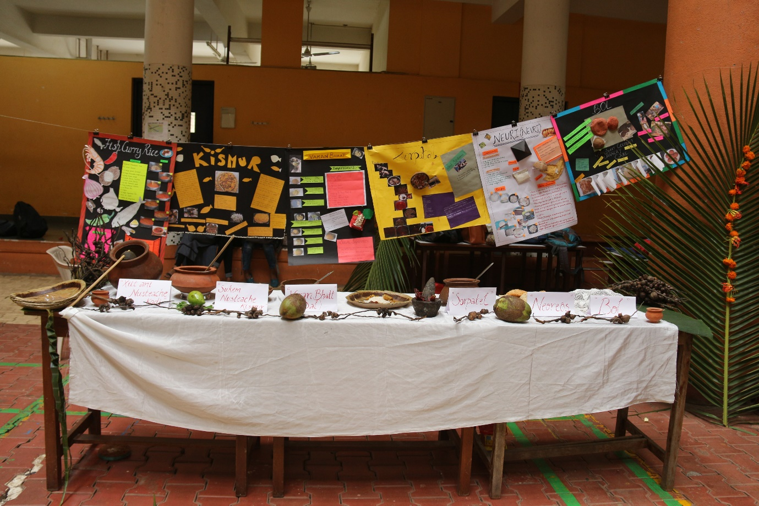

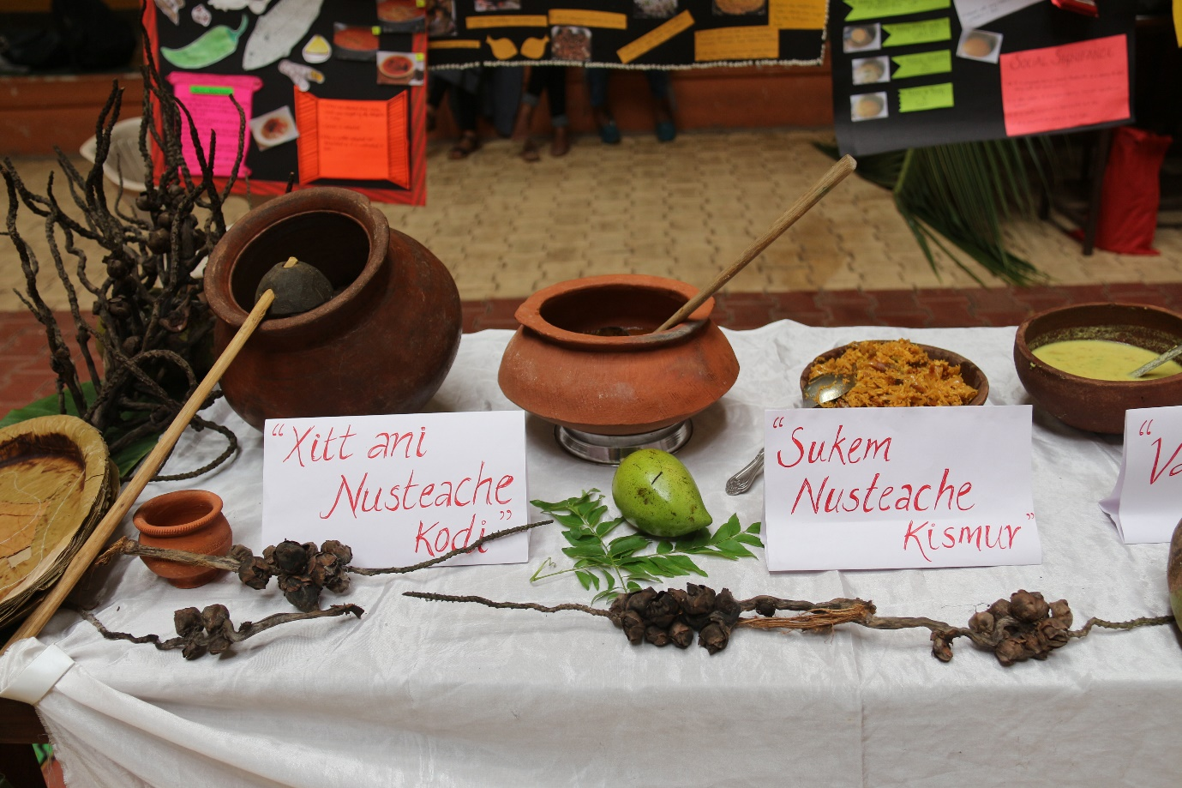
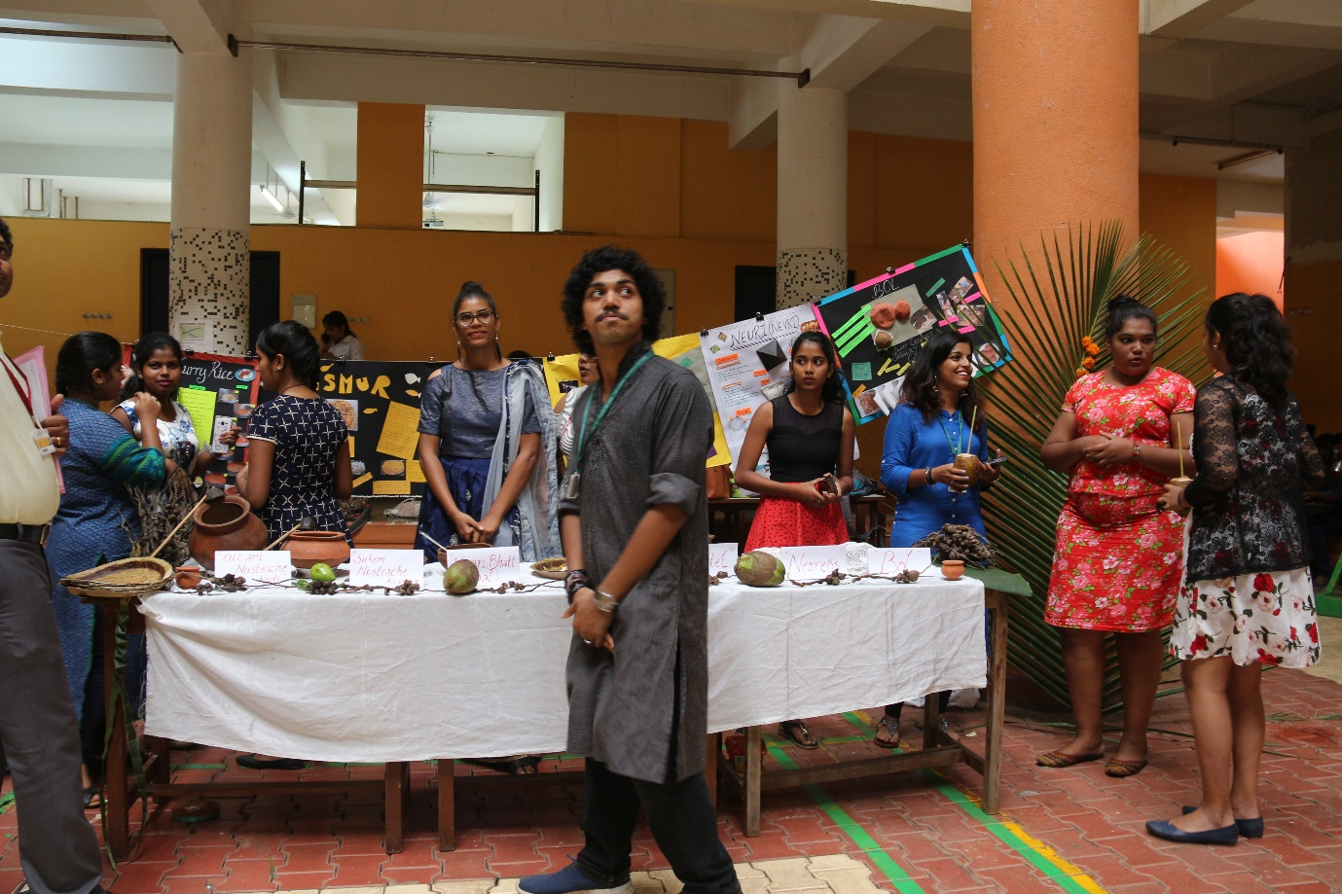
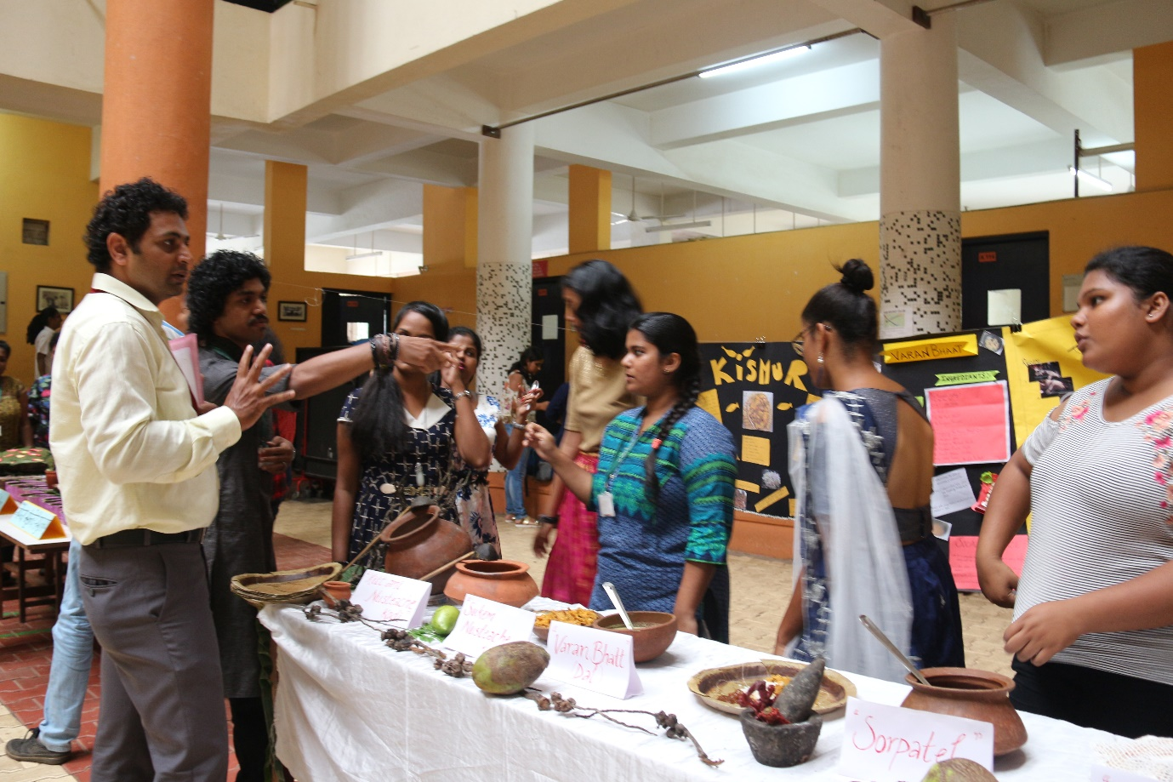

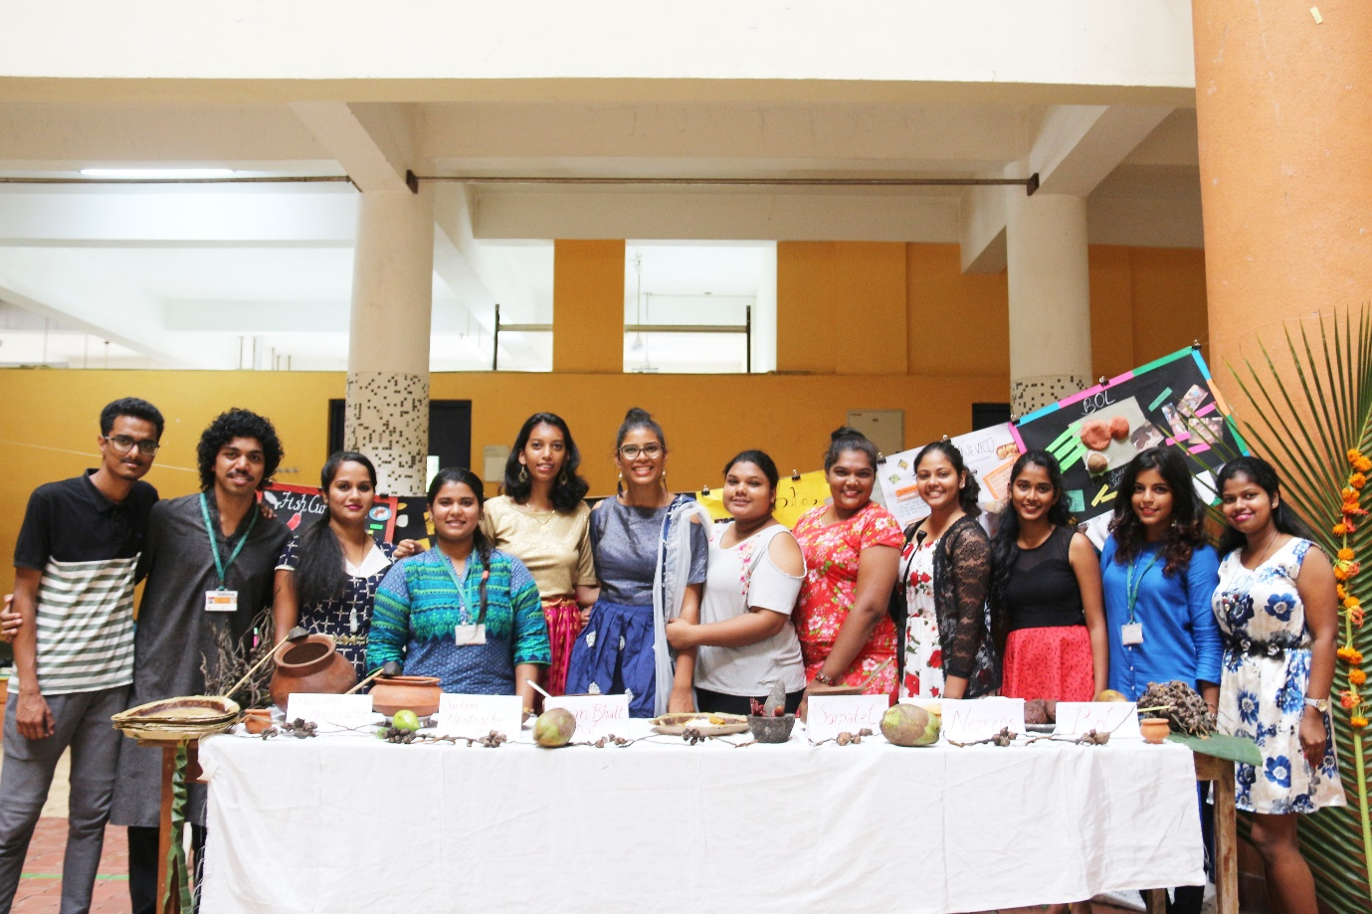
Group 2
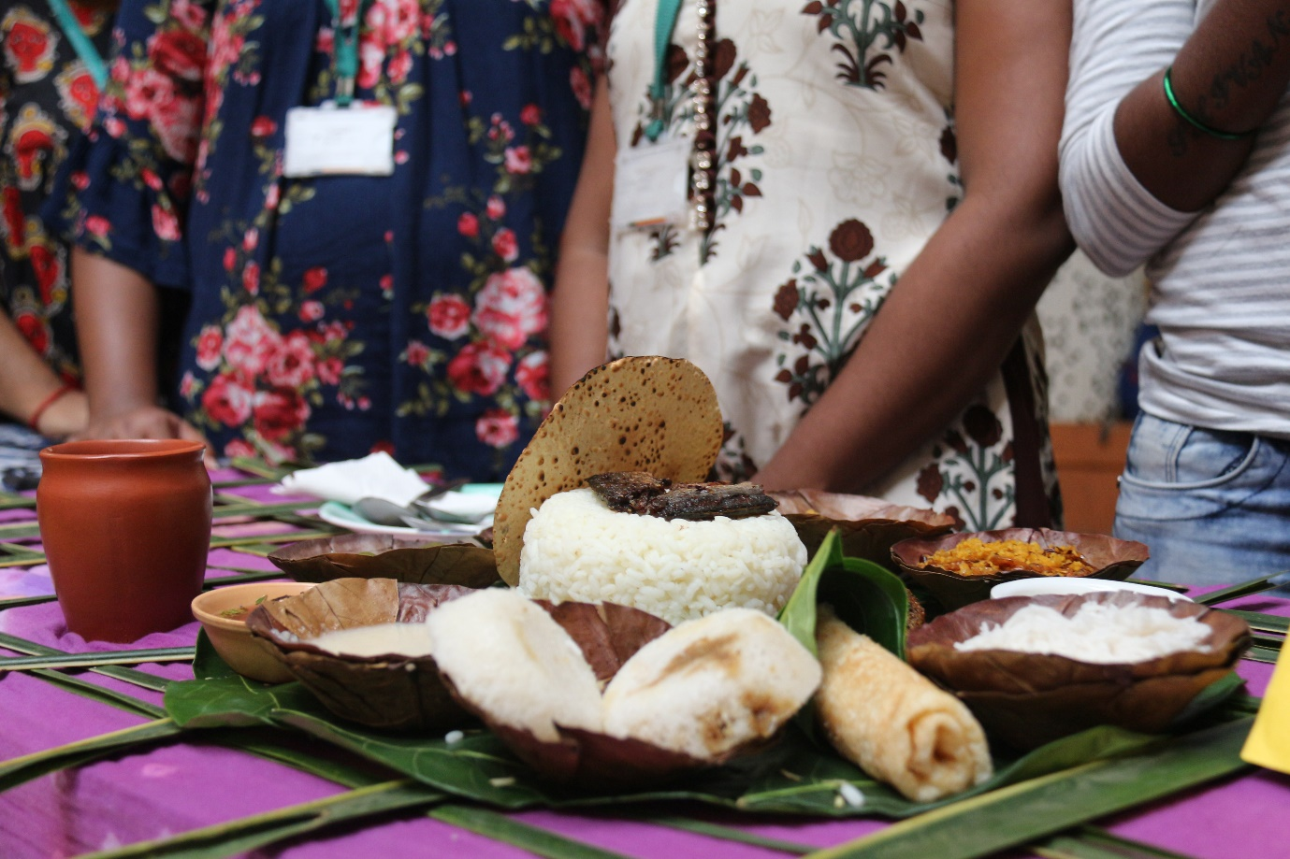

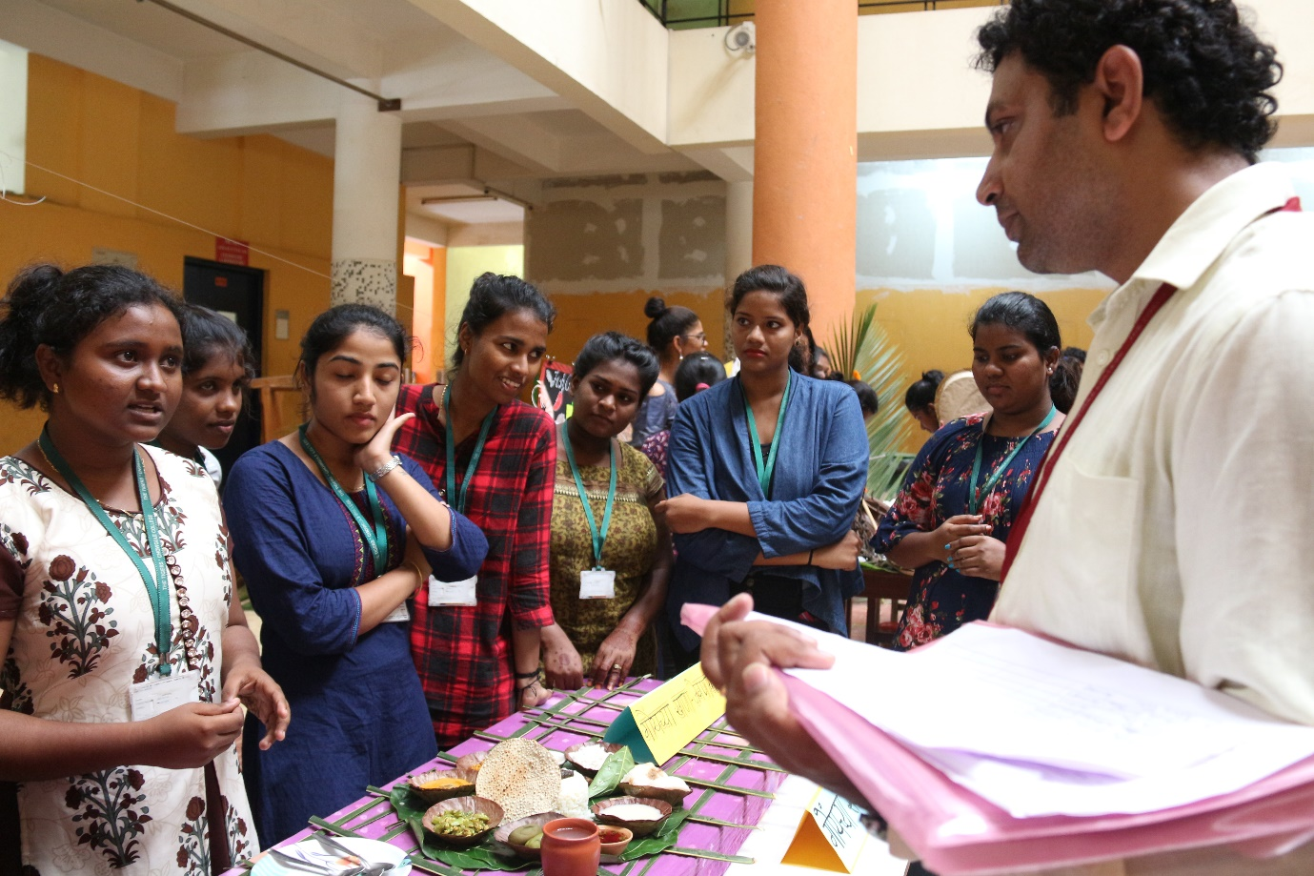
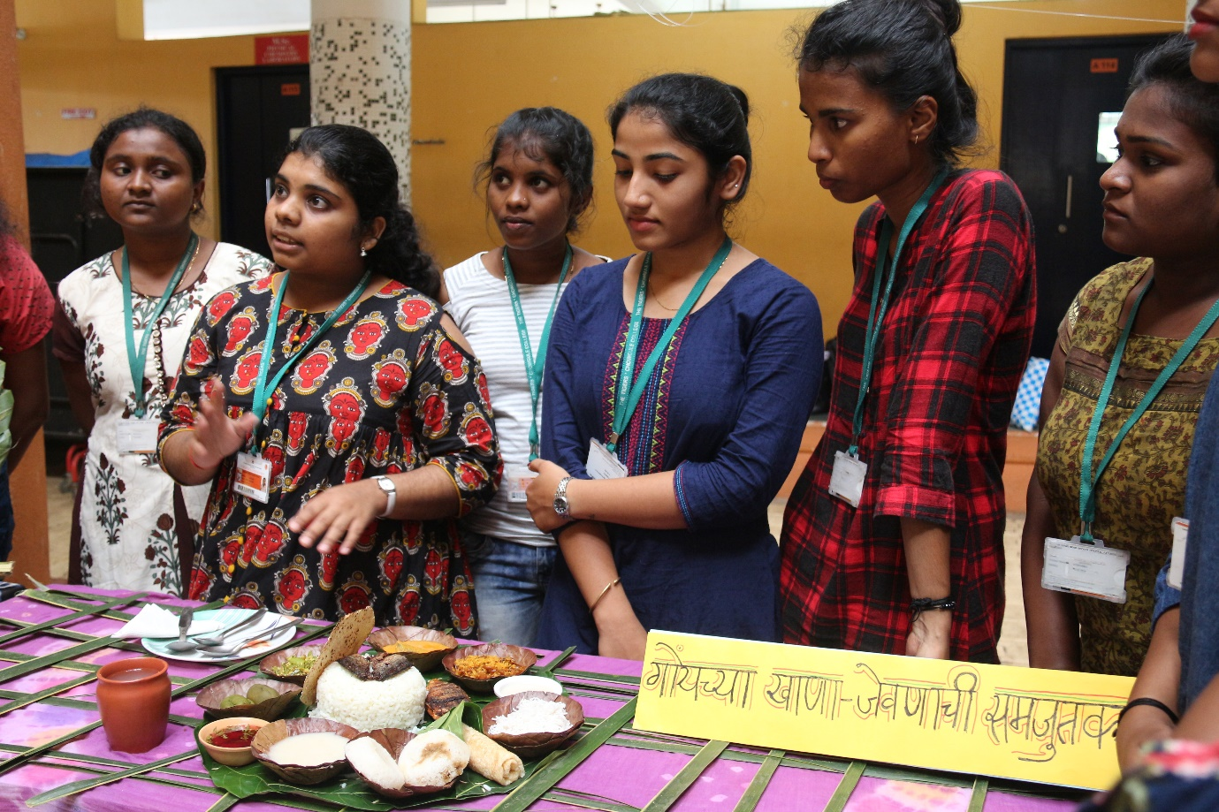

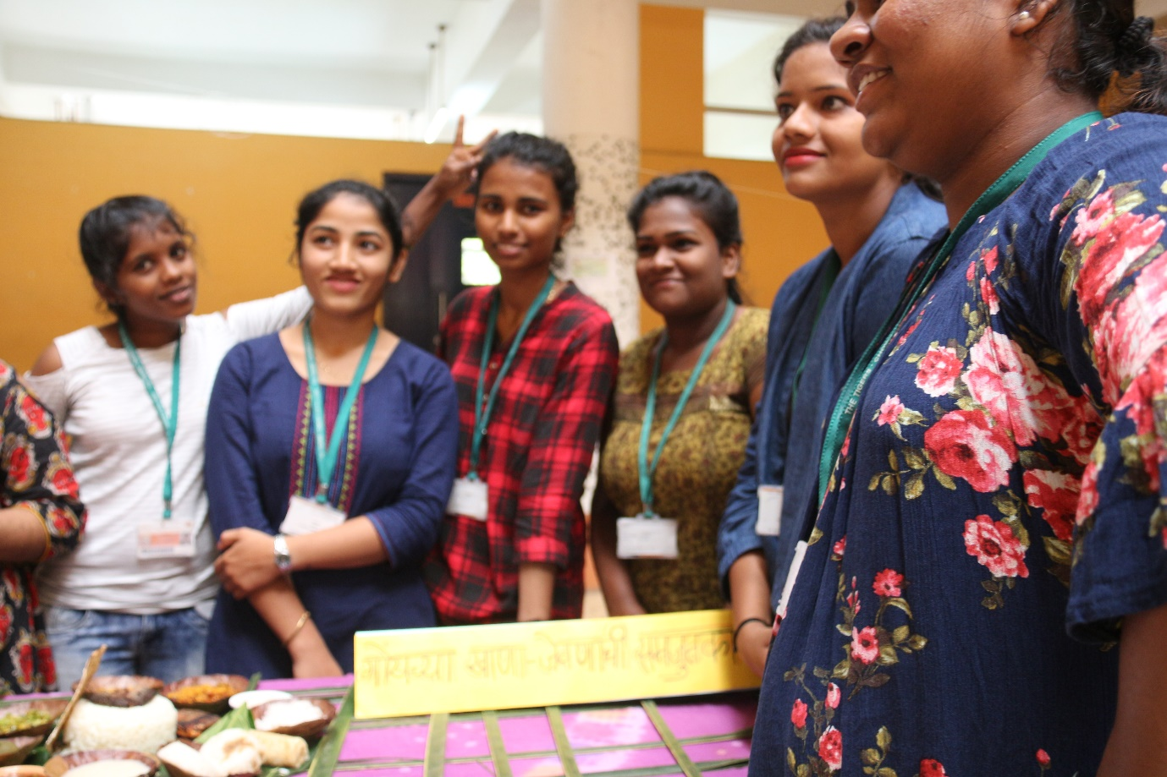
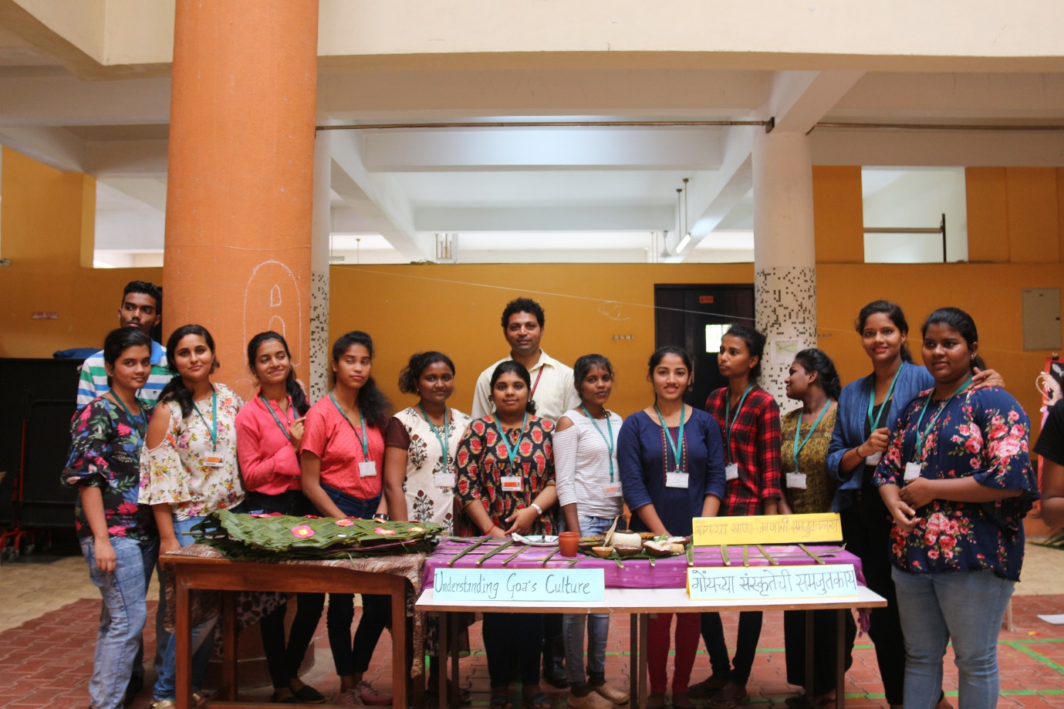

Group 3
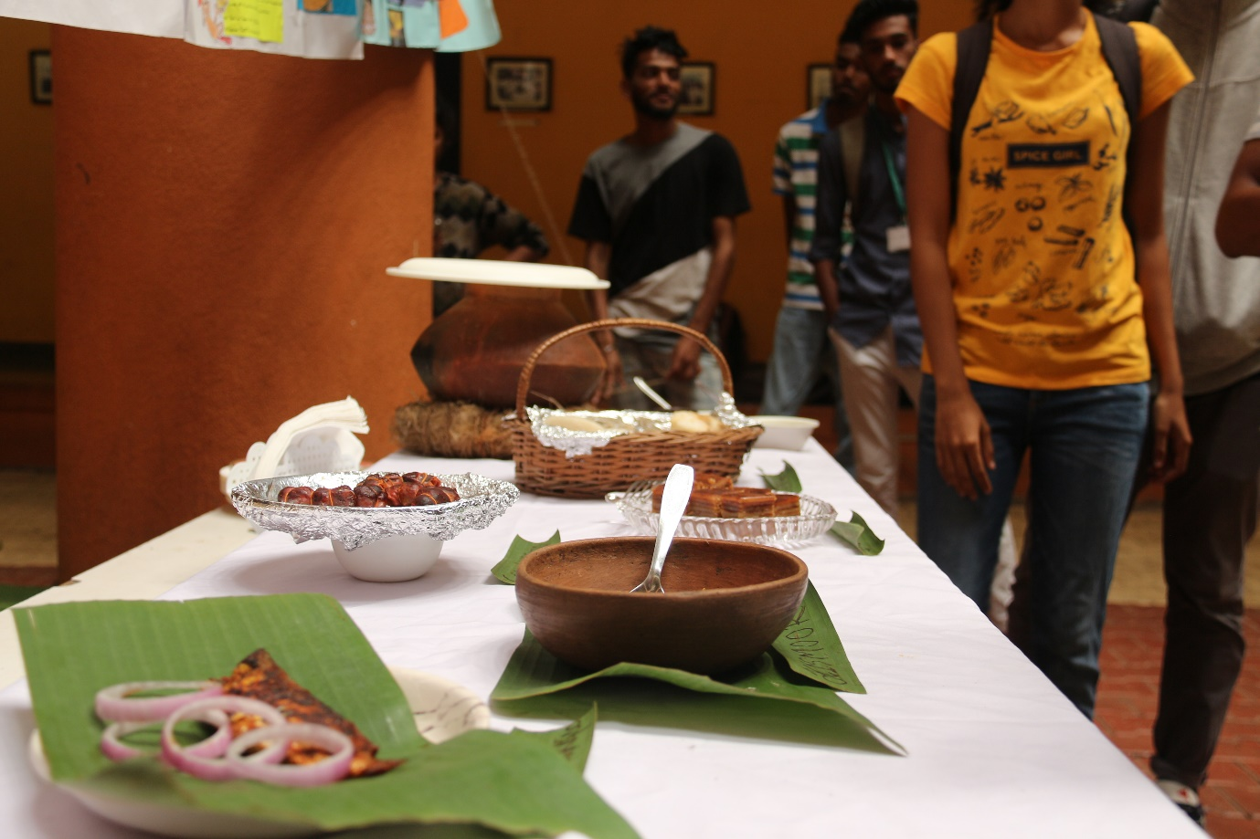
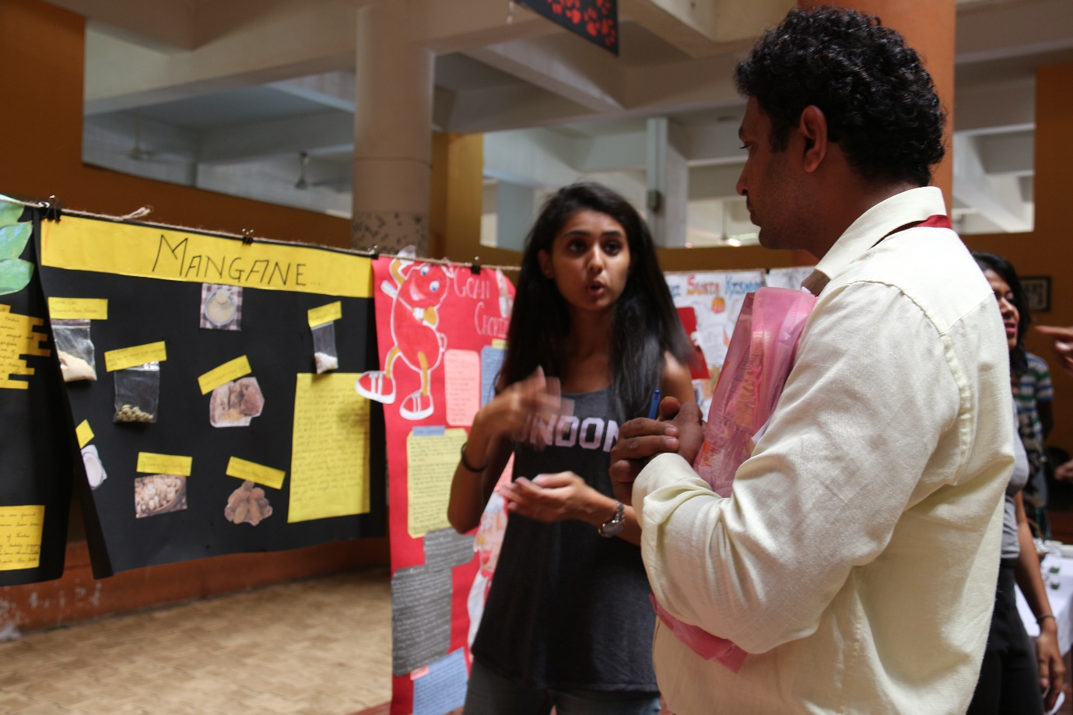

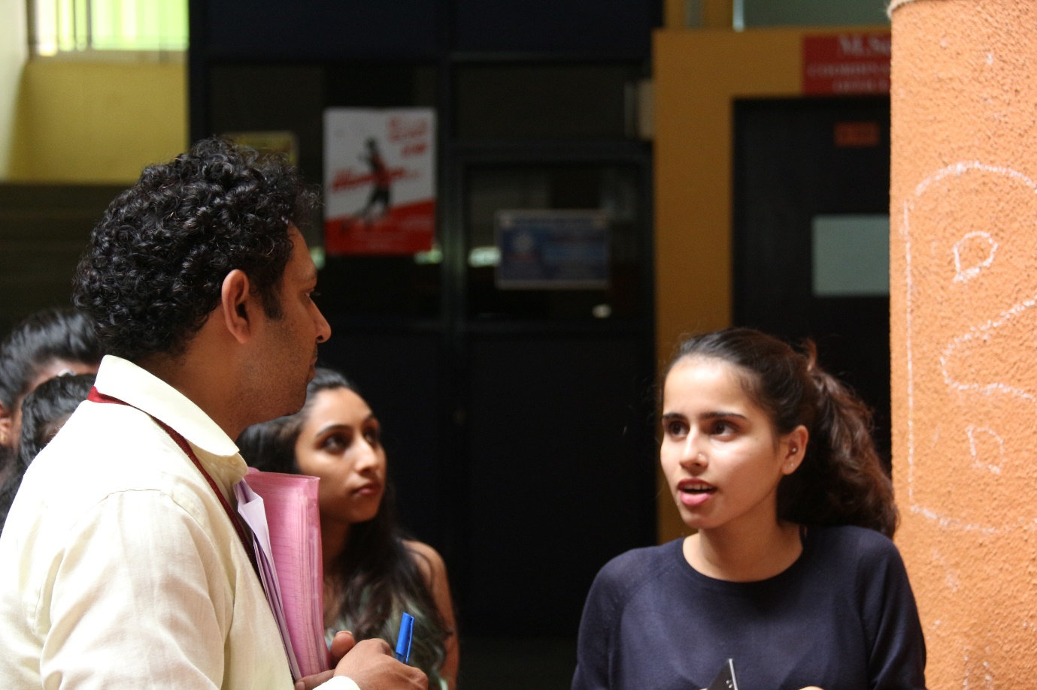
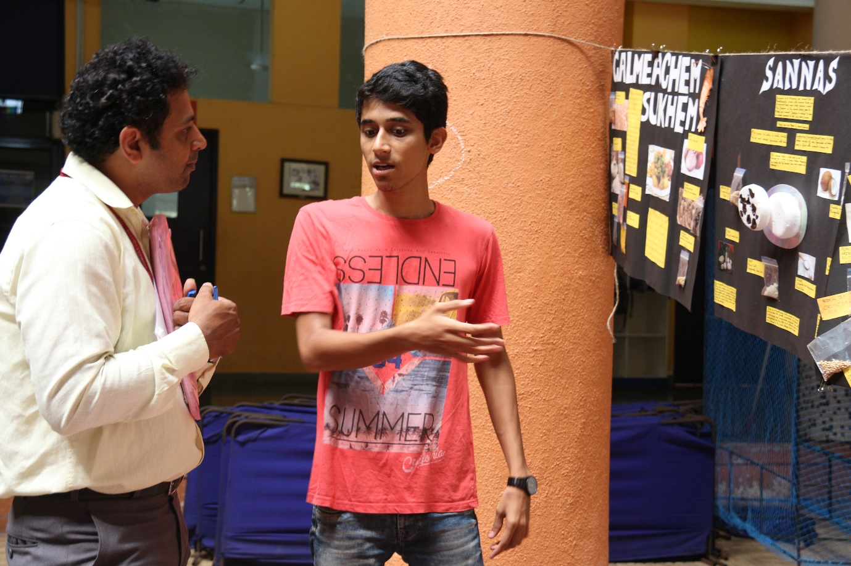

Group 4
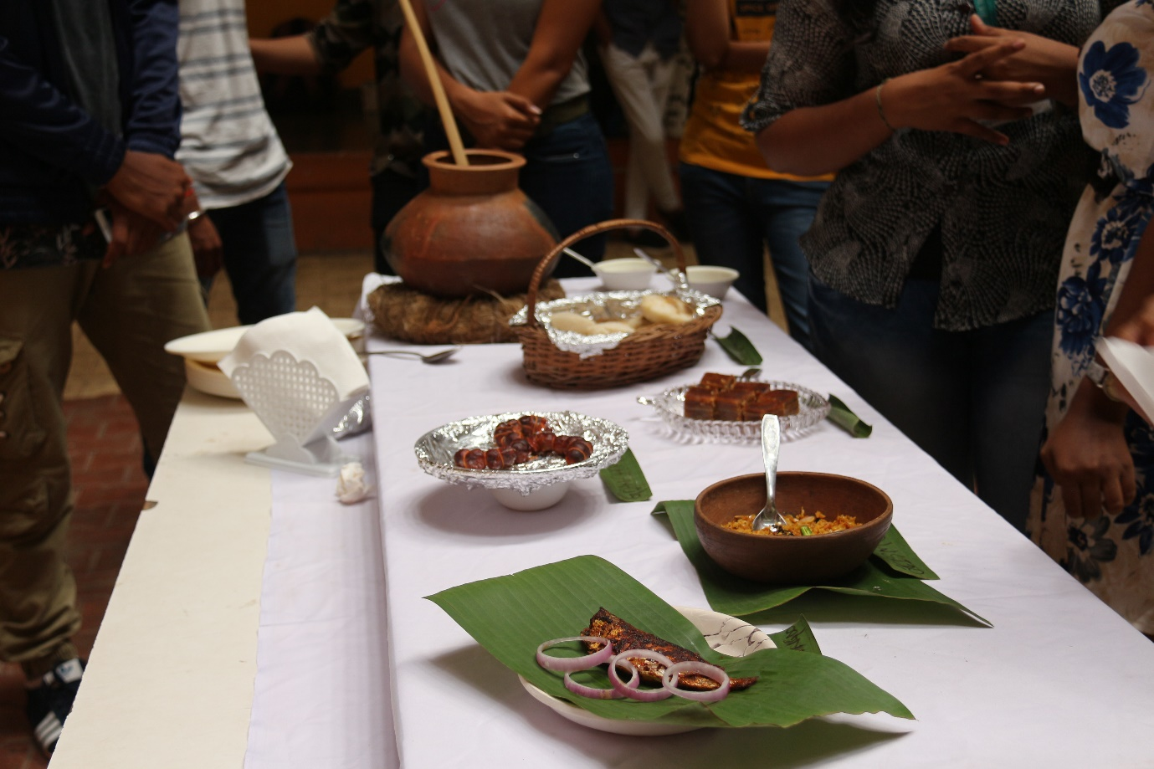
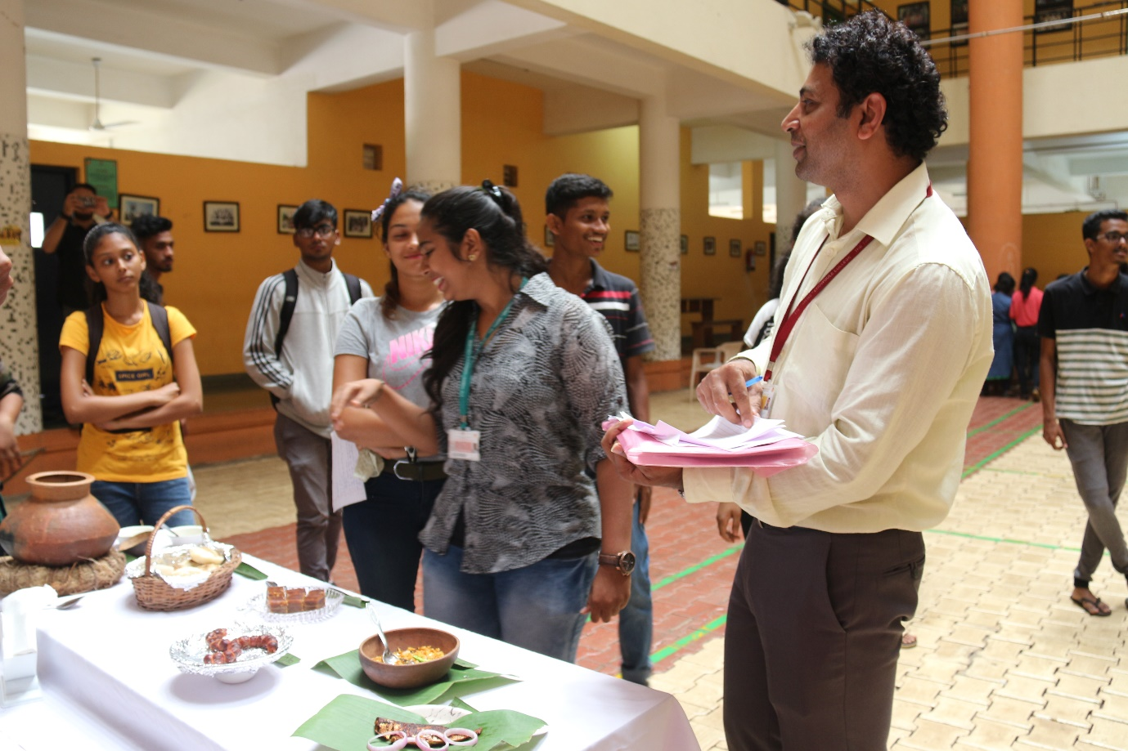

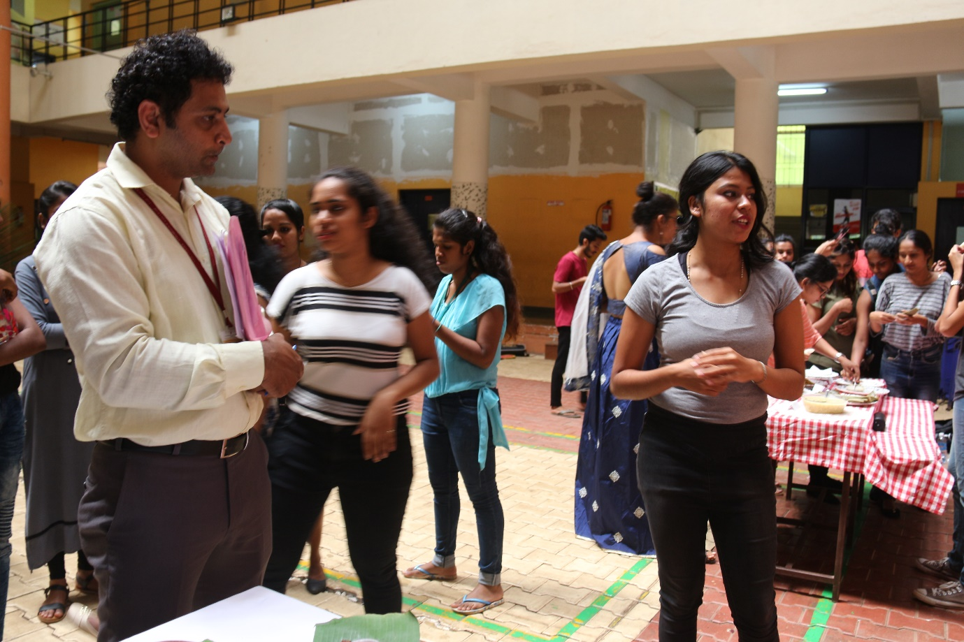
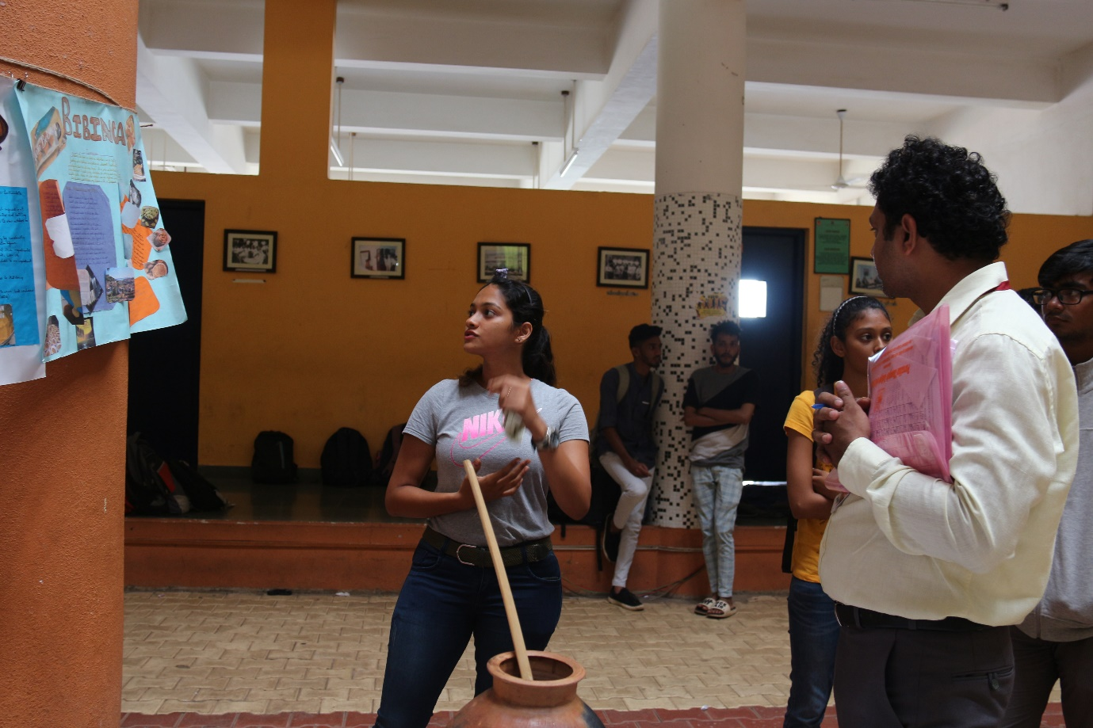

Conclusion
Thus the students increased awareness and to develop their curiosity towards the target culture and their own, to make comparisons among cultures” (p. 19). Grittner (1996) acknowledges that culture learning should give students multiple opportunities to explore various facets of culture and make meaning of their discoveries. Students being actively involved in the discovery process develops students’ ability for deeper thinking that promotes comparing and contrasting cultures and becoming “more aware of their own metacognitive processes and developed critical thinking skills”. Thus, an inquiry approach to teaching allows students to ask questions that are relevant or particularly interesting to them, collect necessary information, create answers by investigation, generate a theory, present their findings to other students, and then formulate new questions that are derived from the original questions.

